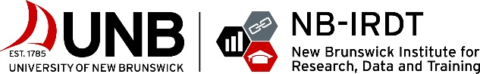
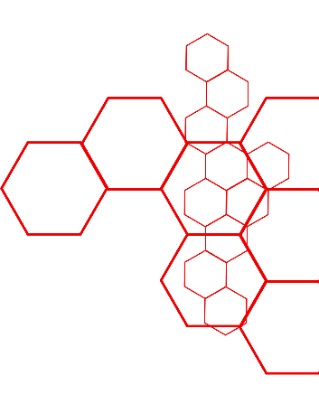
2022 PATHWAYS TO PROFESSIONS
APPLICATION

Pathways to Professions (P2P) is a 13-week paid summer program hosted by the New Brunswick Institute for Research, Data and Training (NB-IRDT) at the University of New Brunswick. P2P is an entirely virtual work experience that offers students the opportunity to join a professional research team to work on New Brunswick-relevant research projects while attending experiential workplace readiness training sessions.

P2P is an opportunity for students to boost their employment prospects through workplace experience, hands-on learning, weekly skills development workshops, mentorship, networking opportunities, and presentations that showcase their communication skills and research results.

Curious what last year’s students did? Check out the 2021 Program in Review and Promotional Video made by our students!

WHO CAN APPLY?
Our NB-IRDT P2P program is open to undergraduate students at the University of New Brunswick, Saint Thomas University, and Mount Allison University who are enrolled in any field of study at any NB campus.

2022 PROGRAM DATES
May 16 - August 12, 2022

HOW MUCH WILL I BE PAID?
$6,850 – paid in bi-weekly installments* for 35 hours a week.
*Standard payroll deductions apply

WHAT KIND OF WORK WILL I DO?
Students will work together in teams to undertake a research project on a topic relevant to NB. These projects are outlined on page 2 and are led by experienced researchers. Students will engage in tasks to advance these projects, such as interviewing community partners, analyzing open data, creating visualizations and communications tools, reporting outcomes, and/or overseeing project development. The teams are collectively responsible for completing all aspects of their projects. For example, all students will contribute to literature reviews, background research, and presentations.

Students in outreach positions will not be assigned to individual research teams but will focus on design- and communication-based tasks for the program (and NB-IRDT) at large while attending our skills-based workshops alongside the research teams.

HOW DO I SUBMIT MY APPLICATION?
Email your completed application form, 1-page cover letter, 1-page resumé, and unofficial transcripts to nb-irdttraining@unb.ca by March 9, 2022. All applicants will be contacted by April 1, 2022.

Project Information

Project Streams
BoostNB | PopNB | VitalSignsNB
Provides a straight-forward economic analysis of NB to show whether it is progressing toward its key economic goals. | Characterizes NB’s population growth, mobility, and demographics in comparison to other provinces and Canada. | Examines how New Brunswick’s shortage of primary care physicians impacts individuals and the healthcare system.

Each research project will include one communications role and three researcher roles. The researcher role involves analyzing, interpreting, and communicating statistical results. The communications role involves producing research reports and knowledge translation products through drafting, editing, and refining reports, presentations, data visualizations, and other content. These roles share many tasks, and groups work together to complete their projects.

In addition to the research team positions, we are looking to hire two additional students in outreach roles. These roles are not tied to individual research projects but will involve outreach tasks for P2P and NB-IRDT at large, which may include activities such as planning a strategic media campaign and developing media (video, graphics, etc.) using a design-based approach.

Please indicate which Research Stream AND ROLE you are interested IN. You may choose more than one. We ask for students to describe their interest and experience in research and communications on page 5 so that we can build teams with a balance of skills.

BoostNB ☐ | PopNB ☐ | VitalSignsNB ☐
Research / Data Analysis ☐ | Communications ☐ | Outreach ☐

NOTE: Students are not guaranteed their selected roles or research streams. However, preferences will be considered.

Applicant Information

First Name: | Click or tap here to enter text.
Last Name: | Click or tap here to enter text.
Preferred Name: | Click or tap here to enter text.
Pronouns: | Click or tap here to enter text.
DAte of Birth: | Click or tap to enter a date.
Mailing Address:
Street Address  Apartment Number  Province  Postal Code  Country | Click or tap here to enter text.
Phone Number: | Click or tap here to enter text.
School Email: | Click or tap here to enter text.

HOW DID YOU HEAR ABOUT P2P?
Click or tap here to enter text.

Academic Information
UNIVERSITY NAME & CAMPUS LOCATION
Click or tap here to enter text.
WHAT PROGRAM ARE YOU ENROLLED IN?
Click or tap here to enter text.
WHAT YEAR OF STUDY ARE YOU IN?
Undergraduate ☐
1st ☐ | 2nd ☐ | 3rd ☐ | 4th ☐ | 5th ☐
WHAT IS YOUR Cumulative Grade Point Average (CGPA)?
Click or tap here to enter text.
ARE YOU ABLE TO WORK REMOTELY FROM May 16 TO August 12, 2022, MONDAY TO FRIDAY FROM 9AM – 5PM AST?
Yes ☐ | No ☐
Are you eligible to work in Canada?
Yes ☐ | No ☐

NOTE: Please include the contact information for an academic reference:
ACADEMIC REFERENCE INFORMATION  FIRST AND LAST NAME  EMAIL ADDRESS  RELATIONSHIP TO STUDENT | Click or tap here to enter text.

Personal and Professional Information
DO YOU HAVE EXPERIENCE IN RESEARCH, COMMUNICATIONS, OR LEADERSHIP ROLES? IF SO, BRIEFLY DESCRIBE YOUR INVOLVEMENT.
150 words max
Click or tap here to enter text.

OF ALL YOUR ACTIVITIES AND ACCOMPLISHMENTS, WHICH ARE YOU THE MOST PROUD OF AND WHY?
150 words max
Click or tap here to enter text.

WHY ARE YOU APPLYING TO P2P, AND WHAT ARE YOUR EXPECTATIONS OF THE PROGRAM? WHAT SKILLS, KNOWLEDGE, AND EXPERIENCE WOULD YOU LIKE TO GAIN?
150 words max NOTE: You can refer to the 2021 Program in Review for more information.
Click or tap here to enter text.
PLEASE DESCRIBE YOUR INTEREST IN YOUR SELECTED PROJECT STREAM(S).
150 words max
Click or tap here to enter text.
WHAT ARE YOUR EDUCATIONAL AND CAREER GOALS?
150 words max
Click or tap here to enter text.

Pathways to Professions is created and run by the New Brunswick Institute for Research, Data and Training (NB-IRDT). We would like to thank our partners, whose participation has helped make P2P a reality:

